TVS Motor’S

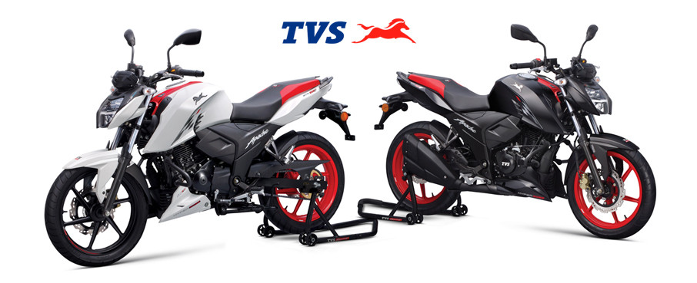Database management System

Overview: -

The **TVS Motor Database** is designed to manage a comprehensive set of data related to a bike showroom, including customers, bikes, sales, services, inventory, payments, and feedback. It tracks details about customers such as their personal information, contact details, and license numbers. The database includes information on various bike models, their specifications, pricing, availability, and launch details. Each bike is linked to its corresponding model and its unique bike details like engine and chassis numbers. The system also manages sales transactions, capturing the sale date, customer, bike sold, sale price, and payment method, ensuring smooth sales management. Additionally, the database handles the employees (sales representatives and technicians) involved in the sales and service processes.

For after-sales support, the database captures detailed service records, service types, technician information, and the parts used in service. It ensures that all parts and services are recorded for warranty and future servicing needs. The inventory system tracks available parts in stock, their costs, and suppliers. Payments are integrated into the system to track both sales and service payments, ensuring complete financial oversight. Feedback is captured from customers post-sale or service, allowing the showroom to monitor satisfaction and address any issues. This integrated structure ensures seamless management of all aspects of the showroom's operations, from sales to service to customer feedback.

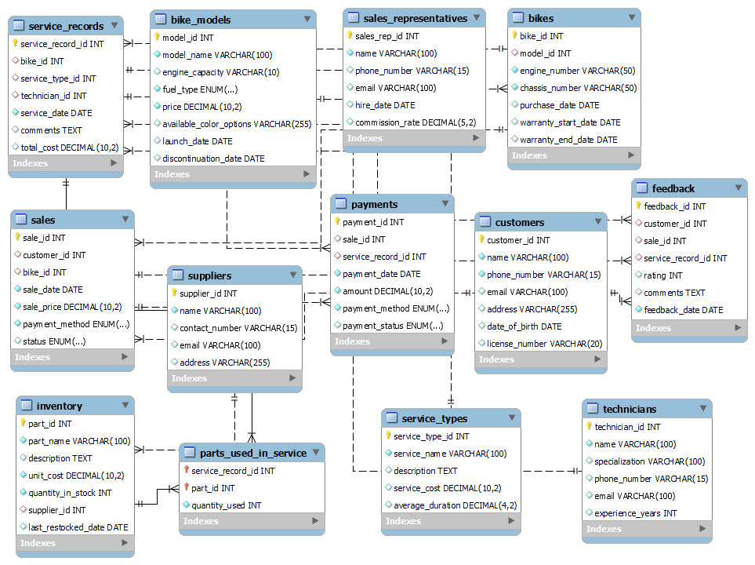ER Diagram

CREATE DATABASE **BIKE_SHOWROOM**;

USE **BIKE_SHOWROOM**;

Create TABLES

-- 01

CREATE TABLE **Customers** (

customer_id INT PRIMARY KEY,

name VARCHAR(100) NOT NULL,

phone_number VARCHAR(15) NOT NULL UNIQUE,

email VARCHAR(100) UNIQUE,

address VARCHAR(255),

date_of_birth DATE,

license_number VARCHAR(20) UNIQUE

);

-- 02

CREATE TABLE **Bike_Models** (

model_id INT PRIMARY KEY,

model_name VARCHAR(100) NOT NULL,

engine_capacity VARCHAR(10),

fuel_type ENUM('Petrol', 'Electric') NOT NULL,

price DECIMAL(10, 2) NOT NULL,

available_color_options VARCHAR(255),

launch_date DATE,

discontinuation_date DATE

);

-- 03

CREATE TABLE **Bikes** (

bike_id INT PRIMARY KEY,

model_id INT,

engine_number VARCHAR(50) UNIQUE NOT NULL,

chassis_number VARCHAR(50) UNIQUE NOT NULL,

purchase_date DATE,

warranty_start_date DATE,

warranty_end_date DATE,

FOREIGN KEY (model_id) REFERENCES Bike_Models(model_id)

);

-- 04

CREATE TABLE **Sales** (

sale_id INT PRIMARY KEY,

customer_id INT,

bike_id INT,

sale_date DATE NOT NULL,

sale_price DECIMAL(10, 2) NOT NULL,

payment_method ENUM('Cash', 'Financing', 'Debit Card') NOT NULL,

status ENUM('Completed', 'Pending', 'Canceled') DEFAULT 'Pending',

FOREIGN KEY (customer_id) REFERENCES Customers(customer_id),

FOREIGN KEY (bike_id) REFERENCES Bikes(bike_id)

);

-- 05

CREATE TABLE **Sales_Representatives** (

sales_rep_id INT PRIMARY KEY,

name VARCHAR(100) NOT NULL,

phone_number VARCHAR(15) UNIQUE,

email VARCHAR(100) UNIQUE,

hire_date DATE,

commission_rate DECIMAL(5, 2)

);

-- 06

CREATE TABLE **Service_Types** (

service_type_id INT PRIMARY KEY,

service_name VARCHAR(100) NOT NULL,

description TEXT,

service_cost DECIMAL(10, 2),

average_duration DECIMAL(4, 2) -- in hours

);

-- 07

CREATE TABLE **Technicians** (

technician_id INT PRIMARY KEY,

name VARCHAR(100) NOT NULL,

specialization VARCHAR(100),

phone_number VARCHAR(15) UNIQUE,

email VARCHAR(100) UNIQUE,

experience_years INT

);

-- 08

CREATE TABLE **Service_Records** (

service_record_id INT PRIMARY KEY,

bike_id INT,

service_type_id INT,

technician_id INT,

service_date DATE NOT NULL,

comments TEXT,

total_cost DECIMAL(10, 2),

FOREIGN KEY (bike_id) REFERENCES Bikes(bike_id),

FOREIGN KEY (service_type_id) REFERENCES Service_Types(service_type_id),

FOREIGN KEY (technician_id) REFERENCES Technicians(technician_id)

);

-- 09

CREATE TABLE **Inventory** (

part_id INT PRIMARY KEY,

part_name VARCHAR(100) NOT NULL,

description TEXT,

unit_cost DECIMAL(10, 2) NOT NULL,

quantity_in_stock INT NOT NULL,

supplier_id INT,

last_restocked_date DATE,

FOREIGN KEY (supplier_id) REFERENCES Suppliers(supplier_id)

);

-- 10

CREATE TABLE **Suppliers** (

supplier_id INT PRIMARY KEY,

name VARCHAR(100) NOT NULL,

contact_number VARCHAR(15),

email VARCHAR(100),

address VARCHAR(255)

);

-- 11

CREATE TABLE **Parts_Used_In_Service** (

service_record_id INT,

part_id INT,

quantity_used INT NOT NULL,

FOREIGN KEY (service_record_id) REFERENCES Service_Records(service_record_id),

FOREIGN KEY (part_id) REFERENCES Inventory(part_id),

PRIMARY KEY (service_record_id, part_id)

);

-- 12

CREATE TABLE **Payments** (

payment_id INT PRIMARY KEY,

sale_id INT,

service_record_id INT,

payment_date DATE NOT NULL,

amount DECIMAL(10, 2) NOT NULL,

payment_method ENUM('Cash', 'Debit Card', 'UPI') NOT NULL,

payment_status ENUM('Paid', 'Unpaid', 'Pending') DEFAULT 'Pending',

FOREIGN KEY (sale_id) REFERENCES Sales(sale_id),

FOREIGN KEY (service_record_id) REFERENCES Service_Records(service_record_id)

);

-- 13

CREATE TABLE **Feedback** (

feedback_id INT PRIMARY KEY,

customer_id INT,

sale_id INT,

service_record_id INT,

rating INT CHECK (rating BETWEEN 1 AND 5),

comments TEXT,

feedback_date DATE NOT NULL,

FOREIGN KEY (customer_id) REFERENCES Customers(customer_id),

FOREIGN KEY (sale_id) REFERENCES Sales(sale_id),

FOREIGN KEY (service_record_id) REFERENCES Service_Records(service_record_id)

);

INSERT VALUES

INSERT INTO **Customers** (customer_id, name, phone_number, email, address, date_of_birth, license_number) VALUES

(1, 'Rohan Sharma', '9876543210', 'rohan.sharma@example.com', 'Mumbai, Maharashtra', '1990-05-15', 'MH01A12345'),

(2, 'Aarti Gupta', '9123456789', 'aarti.gupta@example.com', 'Delhi, Delhi', '1985-11-20', 'DL05B67890'),

(3, 'Vikram Desai', '9823456780', 'vikram.desai@example.com', 'Bangalore, Karnataka', '1993-04-12', 'KA03C11223'),

(4, 'Sanjana Iyer', '9876543123', 'sanjana.iyer@example.com', 'Chennai, Tamil Nadu', '1988-09-18', 'TN09D22456'),

(5, 'Abhishek Verma', '9988776655', 'abhishek.verma@example.com', 'Pune, Maharashtra', '1995-02-02', 'MH12E33445'),

(6, 'Rahul Mehta', '9123456721', 'rahul.mehta@example.com', 'Ahmedabad, Gujarat', '1989-03-11', 'GJ01A78945'),

(7, 'Pooja Singh', '9876543222', 'pooja.singh@example.com', 'Kolkata, West Bengal', '1992-08-27', 'WB09B12345'),

(8, 'Aniket Kumar', '9801234567', 'aniket.kumar@example.com', 'Lucknow, Uttar Pradesh', '1985-07-16', 'UP14C56789'),

(9, 'Rekha Patel', '9776543219', 'rekha.patel@example.com', 'Indore, Madhya Pradesh', '1993-12-23', 'MP09D34567'),

(10, 'Neeraj Kapoor', '9445678901', 'neeraj.kapoor@example.com', 'Hyderabad, Telangana', '1987-01-29', 'TS08E98765');

INSERT INTO **Bike_Models** (model_id, model_name, engine_capacity, fuel_type, price, available_color_options, launch_date) VALUES

(1, 'TVS Apache RTR 160', '160cc', 'Petrol', 114000, 'Red, Blue, Black', '2020-01-15'),

(2, 'TVS Ntorq 125', '125cc', 'Petrol', 83000, 'Yellow, Red, Blue, Black', '2019-06-10'),

(3, 'TVS Jupiter', '110cc', 'Petrol', 75000, 'Grey, Blue, White, Black', '2018-09-20'),

(4, 'TVS XL100', '100cc', 'Petrol', 54000, 'Green, Black', '2017-04-25'),

(5, 'TVS iQube Electric', '0cc', 'Electric', 140000, 'White, Black', '2021-02-01'),

(6, 'TVS Apache RTR 200', '200cc', 'Petrol', 130000, 'Red, Black, White', '2021-07-10'),

(7, 'TVS Radeon', '110cc', 'Petrol', 70000, 'Black, Grey, Beige', '2018-10-12'),

(8, 'TVS Star City+', '110cc', 'Petrol', 69000, 'Red, Black, Grey', '2019-08-01'),

(9, 'TVS Sport', '100cc', 'Petrol', 62000, 'Blue, Black, Red', '2020-05-15'),

(10, 'TVS Zest Electric', '0cc', 'Electric', 145000, 'Yellow, Black', '2023-01-30'),

(11, 'TVS Electron+', '0cc', 'Electric', 160000, 'Blue, Black, White', '2024-02-15'),

(12, 'TVS Blaze E+', '0cc', 'Electric', 175000, 'Red, Silver', '2024-03-22'),

(13, 'TVS Spark E', '0cc', 'Electric', 140000, 'Black, Blue', '2024-04-05'),

(14, 'TVS Evo Electric', '0cc', 'Electric', 180000, 'White, Silver', '2024-06-01'),

(15, 'TVS Creon', '0cc', 'Electric', 170000, 'White, Red, Grey', '2023-08-05');

INSERT INTO **Bikes** (bike_id, model_id, engine_number, chassis_number, purchase_date, warranty_start_date, warranty_end_date) VALUES

(1, 1, 'ENG123456789', 'CHS987654321', '2024-01-20', '2024-01-20', '2026-01-20'),

(2, 2, 'ENG987654321', 'CHS123456789', '2023-11-05', '2023-11-05', '2025-11-05'),

(3, 3, 'ENG567890123', 'CHS456789012', '2024-03-15', '2024-03-15', '2026-03-15'),

(4, 4, 'ENG135790246', 'CHS357924680', '2024-05-30', '2024-05-30', '2026-05-30'),

(5, 5, 'ENG246813579', 'CHS468135792', '2023-10-10', '2023-10-10', '2025-10-10'),

(6, 6, 'ENG112233445', 'CHS554433221', '2023-09-18', '2023-09-18', '2025-09-18'),

(7, 7, 'ENG223344556', 'CHS665544332', '2024-01-10', '2024-01-10', '2026-01-10'),

(8, 8, 'ENG334455667', 'CHS776655443', '2024-02-22', '2024-02-22', '2026-02-22'),

(9, 9, 'ENG445566778', 'CHS887766554', '2023-12-01', '2023-12-01', '2025-12-01'),

(10, 10, 'ENG556677889', 'CHS998877665', '2024-03-14', '2024-03-14', '2026-03-14'),

(11, 11, 'ENG667788990', 'CHS009988776', '2024-04-05', '2024-04-05', '2026-04-05'),

(12, 12, 'ENG778899001', 'CHS110099887', '2024-05-20', '2024-05-20', '2026-05-20'),

(13, 13, 'ENG889900112', 'CHS221100998', '2023-11-22', '2023-11-22', '2025-11-22'),

(14, 14, 'ENG990011223', 'CHS332211009', '2024-06-01', '2024-06-01', '2026-06-01'),

(15, 15, 'ENG001122334', 'CHS443322110', '2024-07-10', '2024-07-10', '2026-07-10');

INSERT INTO **Sales** (sale_id, customer_id, bike_id, sale_date, sale_price, payment_method, status) VALUES

(1, 1, 1, '2024-01-20', 114000, 'Cash', 'Completed'),

(2, 1, 2, '2023-11-05', 83000, 'Debit Card', 'Completed'),

(3, 3, 3, '2024-03-15', 75000, 'Financing', 'Pending'),

(4, 2, 4, '2024-05-30', 54000, 'Cash', 'Completed'),

(5, 1, 5, '2023-10-10', 140000, 'Debit Card', 'Completed'),

(6, 6, 6, '2023-12-15', 130000, 'Cash', 'Completed'),

(7, 10, 7, '2024-02-01', 70000, 'Financing', 'Completed'),

(8, 8, 8, '2024-03-22', 69000, 'Debit Card', 'Completed'),

(9, 9, 9, '2024-01-10', 62000, 'Cash', 'Completed'),

(10, 5, 10, '2024-04-30', 145000, 'Cash', 'Pending'),

(11, 4, 11, '2024-05-05', 160000, 'Debit Card', 'Completed'),

(12, 4, 12, '2024-06-10', 175000, 'Financing', 'Completed'),

(13, 5, 13, '2024-07-15', 140000, 'Cash', 'Completed'),

(14, 7, 14, '2024-08-20', 180000, 'Debit Card', 'Pending'),

(15, 10, 15, '2024-09-25', 170000, 'Cash', 'Completed');

INSERT INTO **Service_Types** (service_type_id, service_name, description, service_cost, average_duration) VALUES

(1, 'Regular Maintenance', 'Basic checkup and oil change', 1000, 1.5),

(2, 'Engine Overhaul', 'Complete engine inspection and repair', 5000, 4),

(3, 'Electrical Repair', 'Repair of electrical components', 1500, 2),

(4, 'Brake Service', 'Brake inspection and replacement', 800, 1),

(5, 'Tyre Replacement', 'Replace old tyres with new ones', 1200, 1);

INSERT INTO **Service_Records** (service_record_id, bike_id, service_type_id, technician_id, service_date, comments, total_cost) VALUES

(1, 1, 1, 101, '2024-01-22', 'Regular maintenance done', 1000),

(2, 2, 3, 102, '2023-11-10', 'Fixed electrical wiring issues', 1500),

(3, 3, 2, 101, '2024-03-20', 'Engine overhaul completed', 5000),

(4, 4, 4, 103, '2024-06-01', 'Brake pads replaced', 800),

(5, 5, 5, 104, '2023-10-15', 'Front tyre replaced', 1200),

(6, 6, 1, 101, '2024-01-15', 'Regular maintenance performed', 900),

(7, 7, 2, 102, '2024-02-05', 'Oil change and filter replacement', 1200),

(8, 8, 3, 103, '2024-03-10', 'Battery replacement completed', 2000),

(9, 9, 4, 104, '2024-04-22', 'Chain lubrication and adjustment', 500),

(10, 10, 5, 101, '2024-05-01', 'General check-up', 700),

(11, 11, 1, 102, '2024-06-15', 'Brake system inspection', 800),

(12, 12, 2, 103, '2024-07-20', 'Tire rotation and balance', 1100),

(13, 13, 3, 104, '2024-08-30', 'Engine diagnostic check', 1500),

(14, 14, 4, 101, '2024-09-05', 'Clutch adjustment done', 900),

(15, 15, 5, 102, '2024-10-18', 'Battery check and replacement', 1800);

INSERT INTO **Technicians** (technician_id, name, specialization, phone_number, email, experience_years) VALUES

(101, 'Arjun Patel', 'Engine Repair', '9876543120', 'arjun.patel@tvsmotors.com', 5),

(102, 'Priya Nair', 'Electrical Work', '9123456710', 'priya.nair@tvsmotors.com', 3),

(103, 'Manish Kumar', 'Brake Service', '9987654321', 'manish.kumar@tvsmotors.com', 4),

(104, 'Swati Joshi', 'Tyre Replacement', '9876501234', 'swati.joshi@tvsmotors.com', 2);

INSERT INTO **Inventory** (part_id, part_name, description, unit_cost, quantity_in_stock, supplier_id, last_restocked_date) VALUES

(1, 'Oil Filter', 'Engine oil filter', 200, 50, 201, '2024-01-10'),

(2, 'Brake Pads', 'Front and rear brake pads', 400, 30, 202, '2024-02-15'),

(3, 'Spark Plug', 'Ignition spark plug', 150, 100, 201, '2024-03-01'),

(4, 'Battery', 'Electric bike battery', 5000, 10, 203, '2024-01-25'),

(5, 'Tyre', 'Standard 17-inch tyre', 1200, 20, 204, '2024-02-05');

INSERT INTO **Suppliers** (supplier_id, name, contact_number, email, address) VALUES

(201, 'Auto Parts Ltd', '9123456789', 'contact@autopartsltd.in', 'Mumbai, Maharashtra'),

(202, 'BrakeMaster Supplies', '9876543210', 'sales@brakemaster.com', 'Delhi, Delhi'),

(203, 'Battery World', '9988776655', 'support@batteryworld.in', 'Bangalore, Karnataka'),

(204, 'TyreHouse', '9898989898', 'info@tyrehouse.com', 'Chennai, Tamil Nadu');

INSERT INTO **Payments** (payment_id, sale_id, service_record_id, payment_date, amount, payment_method, payment_status) VALUES

(1, 1, NULL, '2024-01-20', 114000, 'Cash', 'Paid'),

(2, 2, NULL, '2023-11-05', 83000, 'Debit Card', 'Paid'),

(3, NULL, 1, '2024-01-22', 1000, 'Cash', 'Paid'),

(4, NULL, 3, '2024-03-20', 5000, 'Cash', 'Pending'),

(5, 5, NULL, '2023-10-10', 140000, 'Debit Card', 'Paid'),

(6, 3, NULL, '2024-03-15', 75000, 'Debit Card', 'Pending'),

(7, 4, NULL, '2024-05-30', 54000, 'Cash', 'Paid'),

(8, NULL, 2, '2023-11-15', 1500, 'UPI', 'Paid'),

(9, NULL, 4, '2024-06-01', 800, 'UPI', 'Paid'),

(10, 6, NULL, '2024-01-15', 130000, 'Debit Card', 'Paid'),

(11, NULL, 5, '2024-03-10', 1200, 'Cash', 'Pending'),

(12, 7, NULL, '2024-04-22', 70000, 'Debit Card', 'Paid'),

(13, NULL, 6, '2024-07-01', 500, 'UPI', 'Paid'),

(14, 8, NULL, '2024-05-10', 69000, 'Cash', 'Paid'),

(15, NULL, 7, '2024-08-25', 2000, 'UPI', 'Paid');

INSERT INTO **Feedback** (feedback_id, customer_id, sale_id, service_record_id, rating, comments, feedback_date) VALUES

(1, 1, 1, NULL, 5, 'Great service and bike quality!', '2024-01-25'),

(2, 2, 2, NULL, 4, 'Happy with the purchase, but delivery was delayed.', '2023-11-15'),

(3, 2, NULL, 3, 5, 'Excellent service, bike feels new!', '2024-03-25'),

(4, 4, NULL, 4, 3, 'Brake service was satisfactory.', '2024-06-05'),

(5, 5, 5, NULL, 5, 'Love the iQube, fantastic experience!', '2023-10-20'),

(6, 3, 6, NULL, 4, 'Overall good experience, bike is smooth.', '2024-02-05'),

(7, 7, NULL, 2, 5, 'Service was quick and effective!', '2024-04-10'),

(8, 8, NULL, 5, 2, 'Expected better quality after service.', '2024-05-15'),

(9, 9, NULL, 3, 4, 'Bike performance improved significantly after service.', '2024-03-30'),

(10, 1, NULL, NULL, 5, 'The sales staff was very helpful and knowledgeable.', '2024-01-10'),

(11, 9, 7, NULL, 4, 'Great bike, but the color options are limited.', '2024-02-20'),

(12, 10, NULL, 6, 3, 'Satisfactory service, but could be improved.', '2024-06-15'),

(13, 2, NULL, 4, 5, 'Amazing experience with the service team!', '2024-07-01'),

(14, 1, 8, NULL, 4, 'Pleased with the bike performance.', '2024-05-20'),

(15, 3, NULL, 1, 5, 'Love my new bike! Highly recommend!', '2024-08-10');

INSERT INTO **Sales_Representatives** (sales_rep_id, name, phone_number, email, hire_date, commission_rate) VALUES

(1, 'Amit Sharma', '9876543210', 'amit.sharma@example.com', '2021-04-15', 0.05),

(2, 'Priya Desai', '9823456789', 'priya.desai@example.com', '2022-06-20', 0.04),

(3, 'Rajesh Kumar', '9988776655', 'rajesh.kumar@example.com', '2023-01-10', 0.06),

(4, 'Sneha Verma', '9876512345', 'sneha.verma@example.com', '2020-09-01', 0.03),

(5, 'Vikram Joshi', '9765432109', 'vikram.joshi@example.com', '2019-11-05', 0.07),

(6, 'Meera Patel', '9898765432', 'meera.patel@example.com', '2023-07-18', 0.05);

Select & DESC

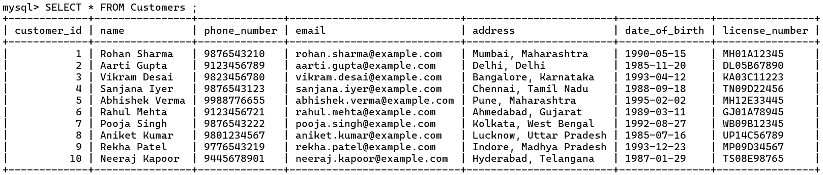SELECT * FROM Customers ;

SELECT * FROM Service_Records ;

SELECT * FROM Technicians ;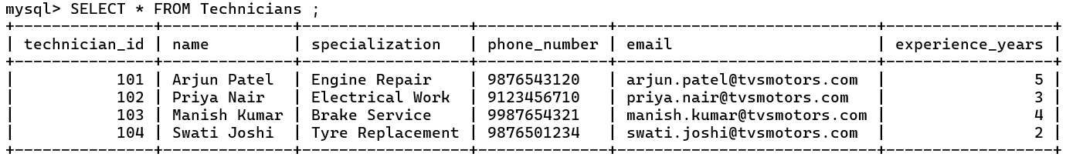

SELECT * FROM Payments ;

DESC Customers ; 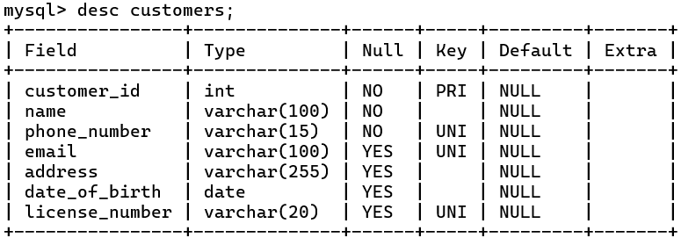

DESC Bikes ;

DESC Sales ; 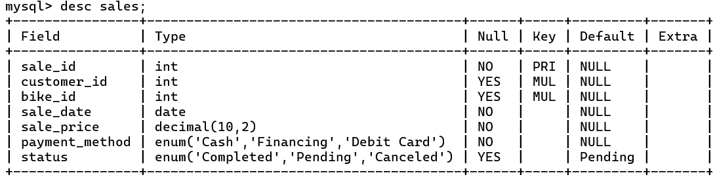

DESC Service_Types ;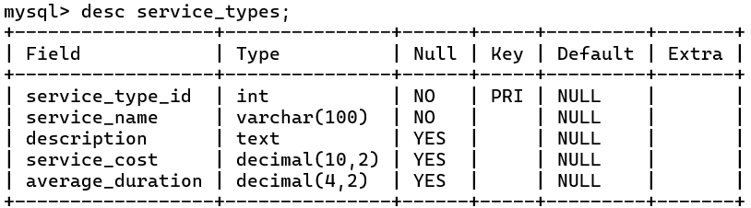

DESC Sales_Representatives ;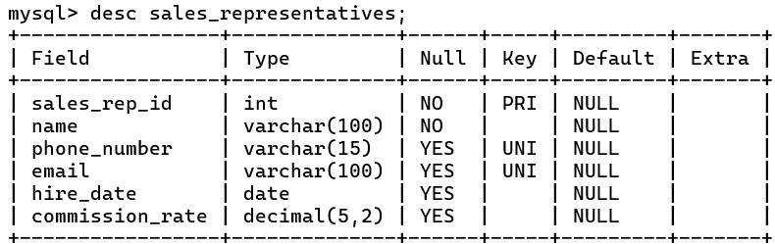

DESC Suppliers ;

DESC Payments ;

*** QUESTIONS ***

-- find engine capacities greater than 110cc

SELECT *

FROM Bike_Models

WHERE ENGINE_CAPACITY > 110;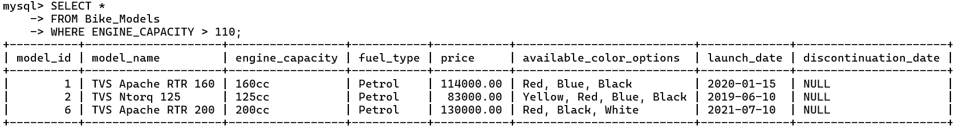

-- CHANGE CUSTOMER ADD FOR CUST_ID 3?

UPDATE CUSTOMERS

SET ADDRESS = 'MUMBAI,MAHARASHTRA'

WHERE CUSTOMER_ID = 3;

-- List all bike models with their price and fuel type

-- Find all bikes purchased in the year 2024

SELECT bike_id, model_id, purchase_date

FROM Bikes

WHERE YEAR(purchase_date) = 2024;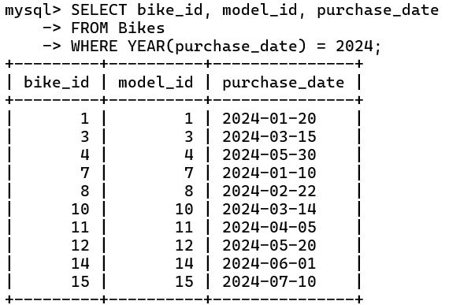

-- Get the total sales amount

-- Find all service records for a specific bike (e.g., bike_id = 1)

SELECT * FROM Service_Records WHERE bike_id = 1;

-- List customers who bought bikes with a specific model (e.g., model_id = 5)

SELECT c.name, c.phone_number

FROM Customers AS c

JOIN Sales AS s ON c.customer_id = s.customer_id

JOIN Bikes AS b ON s.bike_id = b.bike_id

-- Get feedback for all services with a rating of 4 or higher

SELECT customer_id, sale_id, service_record_id, rating, comments

FROM Feedback

WHERE rating >= 4;

-- Find all technicians with more than 3 years of experience

SELECT * FROM Technicians WHERE experience_years > 3;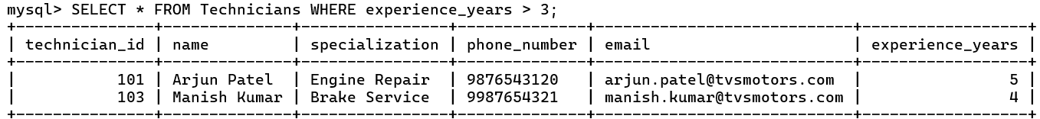

-- Show all bike models available in Electric fuel type

SELECT model_name, price

FROM Bike_Models

-- List out sales representatives hired before 2024

SELECT * FROM Sales_Representatives

WHERE hire_date < '2023-01-01';

-- Find Sales Representatives with a Commission Rate Above 5%

SELECT name, commission_rate

FROM Sales_Representatives

WHERE commission_rate > 0.05;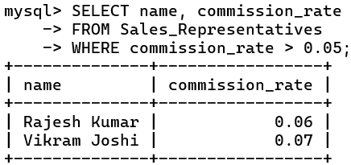

-- Count Total Number of Sales Representatives

SELECT COUNT(*) AS total_sales_reps

FROM Sales_Representatives;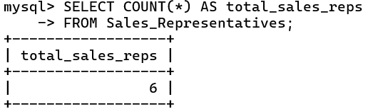

-- Find Sales Representative by Phone Number

SELECT *

FROM Sales_Representatives

WHERE phone_number = '9876543210';

-- Update Commission Rate for a Specific Sales Representative

UPDATE Sales_Representatives

SET commission_rate = 0.06

WHERE sales_rep_id = 3;

-- List Sales Representatives and Their Hire Dates in Descending Order

SELECT name, hire_date

FROM Sales_Representatives

-- Find Bikes Available in a Specific Color:

SELECT model_name, available_color_options

FROM Bike_Models

WHERE available_color_options LIKE '%Red%';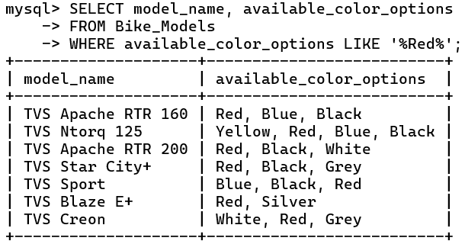

-- Retrieve Bike Models Launched After a Certain Date:

SELECT model_name, launch_date

FROM Bike_Models

-- Count Bikes Sold by Payment Method:

SELECT payment_method, COUNT(*) AS bikes_sold

FROM Sales

GROUP BY payment_method;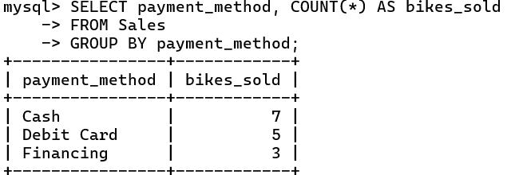

-- Find the Total Number of Bikes Sold to Each Customer:

SELECT c.name AS customer_name, COUNT(s.sale_id) AS total_bikes_sold

FROM Customers c

JOIN Sales s ON c.customer_id = s.customer_id

GROUP BY c.name;

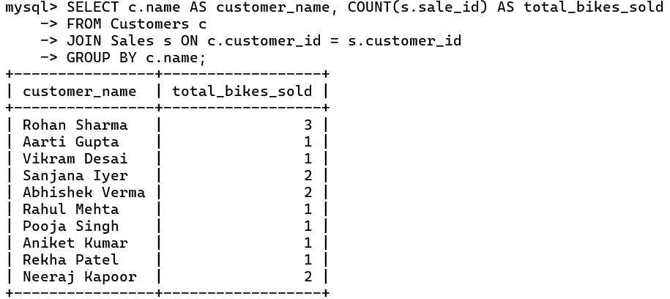

-- Calculate Total Service Costs per Bike:

SELECT b.bike_id, SUM(sr.total_cost) AS total_service_cost

FROM Bikes b

JOIN Service_Records sr ON b.bike_id = sr.bike_id

GROUP BY b.bike_id;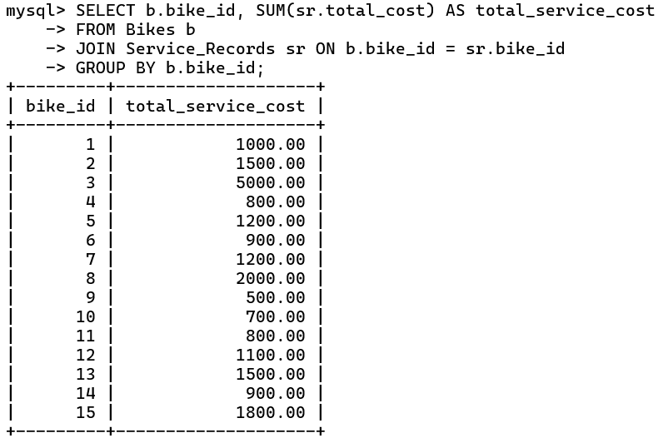

-- Find Customers Who Bought More Than One Bike:

SELECT c.name, COUNT(s.bike_id) AS bikes_purchased

FROM Customers c

JOIN Sales s ON c.customer_id = s.customer_id

GROUP BY c.name

HAVING COUNT(s.bike_id) > 1;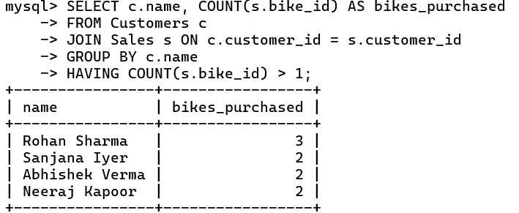

-- Find the bike model with the highest price.

SELECT model_id, model_name, price

FROM Bike_Models

WHERE price = (SELECT MAX(price) FROM Bike_Models);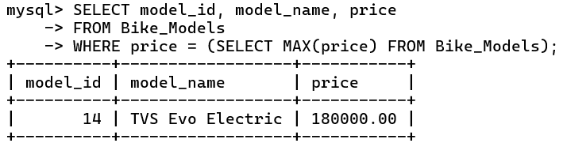

-- Which customer made the most recent purchase?

SELECT customer_id, name, phone_number, email FROM Customers

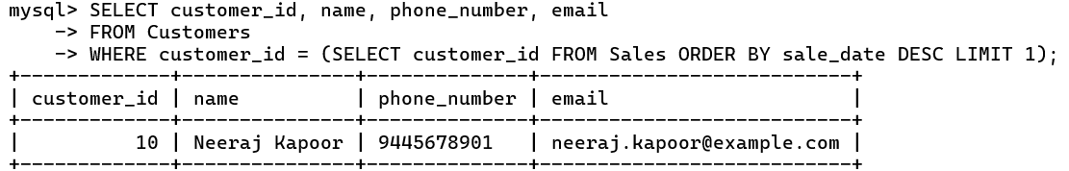WHERE customer_id = (SELECT customer_id FROM Sales ORDER BY sale_date DESC LIMIT 1);

-- Find the customer who made the highest sale for the most expensive bike model.

SELECT name FROM Customers

WHERE customer_id =

(SELECT customer_id FROM Sales

WHERE sale_price =

(SELECT MAX(price) FROM Bike_Models));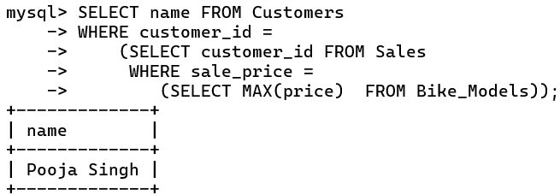

-- Finding the Most Expensive Bike Sold by Each Sales Representative IN DESC ORDER:

SELECT sr.sales_rep_id, sr.name,

(SELECT MAX(s.sale_price)

FROM Sales s

WHERE s.customer_id = sr.sales_rep_id) AS max_sale_price

FROM Sales_Representatives sr

ORDER BY max_sale_price DESC;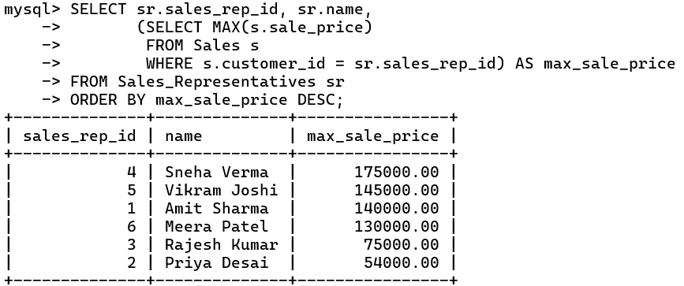

-- Finding the Top 3 Most Popular Bike Models Sold

SELECT bm.model_name, COUNT(s.bike_id) AS sales_count

FROM Sales s

JOIN Bikes b ON s.bike_id = b.bike_id

JOIN Bike_Models bm ON b.model_id = bm.model_id

GROUP BY bm.model_name

ORDER BY sales_count DESC

LIMIT 3;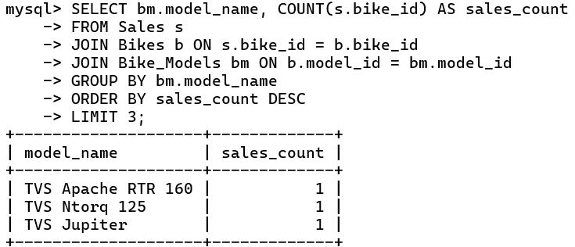

-- retrieves all columns from the Sales table where the sale_price is greater than 1,40,000.

SELECT * FROM Sales WHERE sale_price > 140000;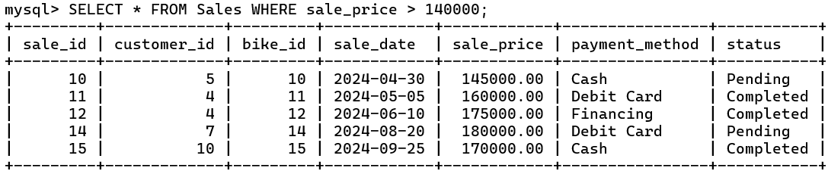

-- retrieves CUST NAME IN ASC ORDER

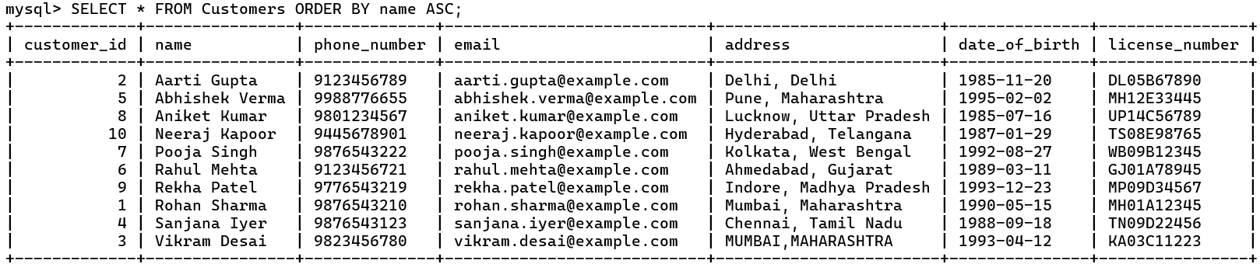SELECT * FROM Customers ORDER BY name ASC;

-- retrieves THE CUSTOMER WHO LIVE IN MAHARASHTRA

SELECT * FROM Customers

WHERE address LIKE '%Maharashtra%';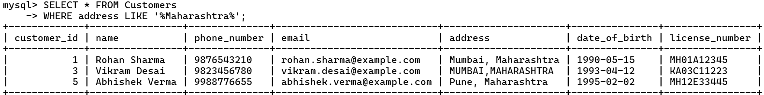

-- Get all the services performed by a specific technician

SELECT SR.service_record_id, SR.bike_id, SR.service_date, SR.comments, SR.total_cost

FROM Service_Records SR

WHERE SR.technician_id = 101;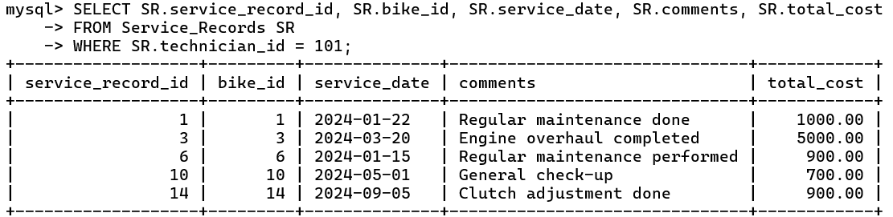

-- Find all service records where the total cost is greater than 1500:

SELECT service_record_id, bike_id, service_date, comments, total_cost

FROM Service_Records

WHERE total_cost > 1500;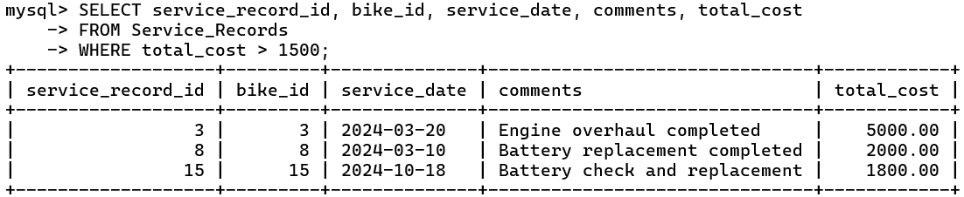

-- Find the number of services performed for each service type:

SELECT ST.service_name, COUNT(SR.service_record_id) AS service_count

FROM Service_Records SR

JOIN Service_Types ST ON SR.service_type_id = ST.service_type_id

GROUP BY ST.service_name;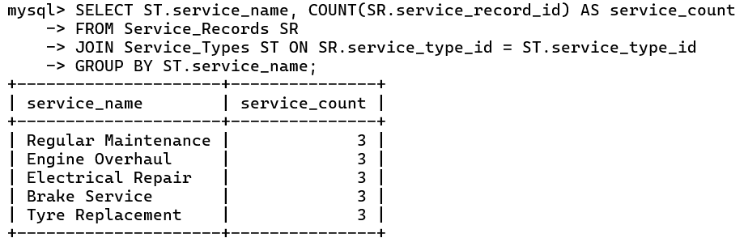

-- Get all records where the service cost is less than 1000:

SELECT service_record_id, bike_id, service_date, comments, total_cost

FROM Service_Records

WHERE total_cost < 1000;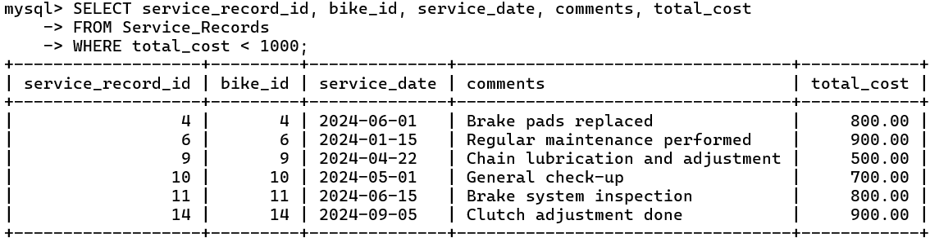

-- Find the most expensive service performed (maximum total cost):

SELECT service_record_id, bike_id, service_type_id, technician_id, service_date, comments, total_cost

FROM Service_Records

WHERE total_cost = (SELECT MAX(total_cost) FROM Service_Records);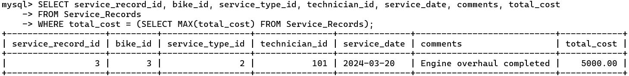

-- Find all services where the service date is after March 1, 2024:

SELECT service_record_id, bike_id, service_type_id, technician_id, service_date, comments, total_cost

FROM Service_Records

WHERE service_date > '2024-03-01' LIMIT 5;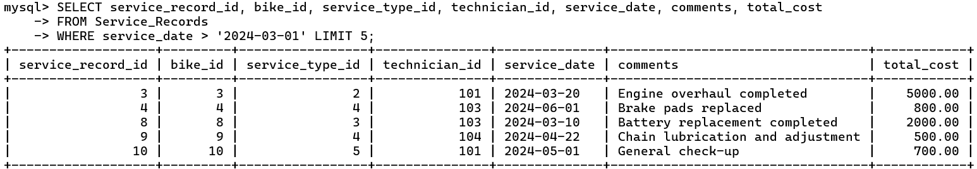

-- Find the service records for bikes serviced by technician 102:

SELECT SR.service_record_id, SR.bike_id, SR.service_date, SR.comments, ST.service_name

FROM Service_Records SR

JOIN Service_Types ST ON SR.service_type_id = ST.service_type_id

WHERE SR.technician_id = 102;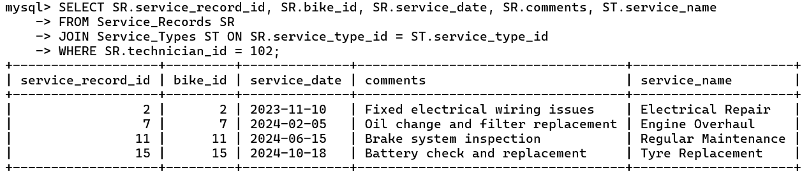

Conclusion :-

The **Bike Showroom Database** is a well-rounded schema that provides efficient handling of sales, inventory, customer, service, and financial data. Its design ensures smooth showroom operations, supports data-driven decision-making, and enhances customer satisfaction by organizing key information across different departments. With this schema, a showroom can maintain comprehensive records, streamline operations, and create a customer-focused approach in both sales and after-sales service areas.

**\*\*\*\*\*\*\*\*\*\*\*\*\*\*\*\*\*\*\*\*\*\*\***

**\*\*\* THE END \*\*\***

**\*\*\*\*\*\*\*\*\*\*\*\*\*\*\*\*\*\*\*\*\*\*\***

**T h a n k Y o u**